Project Members : Shoaib Bin Kabir , Syed Shafkat Raiyan , Hamim Ibne Rahman
Project Overview: SE-STGCN for Bangla Sign Language Recognition with Few-Shot Extensibility
1. Custom Dataset & Lateral Augmentation Pipeline
- Constructed a highly controlled skeletal dataset of 27,201 continuous 60 FPS video clips spanning 184 Bangla Sign Language (BdSL) gestures from 12 signers.
- Implemented an automated FFmpeg-based lateral augmentation pipeline (horizontal flipping) to mathematically balance left- and right-handed gesture variants, expanding the corpus to 49,721 tensor sequences across 342 discrete classes.
- Utilized MediaPipe Holistic to extract 68-node 3D topological graphs capturing precise pose, face anchors, and hand joint coordinates.
- Normalized the spatial-temporal data by applying a 90-frame temporal interpolation and spatial zero-centering to ensure viewpoint and scale invariance across different signers.

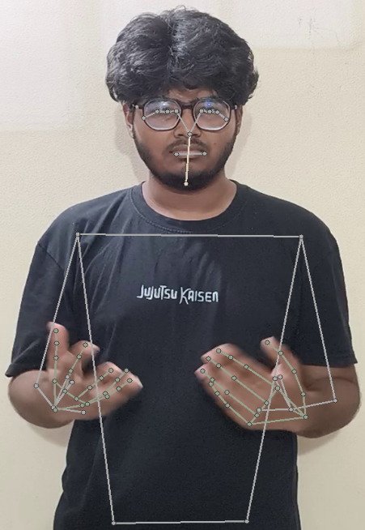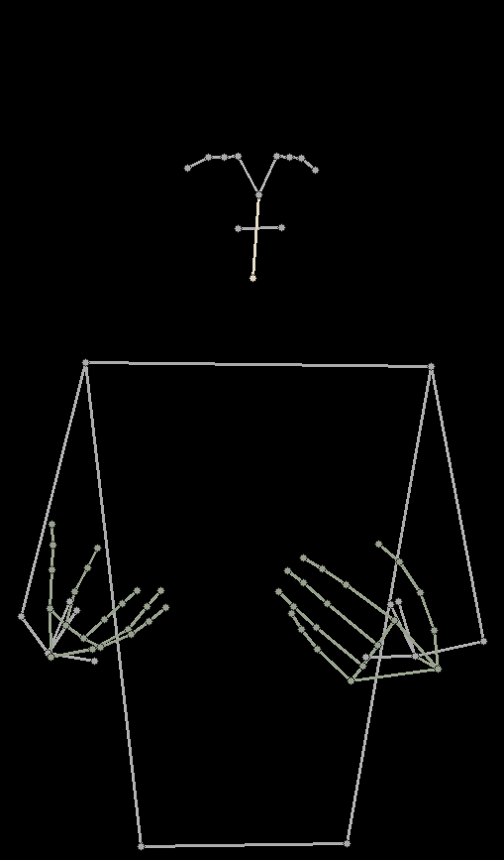
Figure 1- Visual representation of the dataset extraction process, showing the source holistic tracking (a) and the isolated spatial graph (b) that forms the input tensor.

2. SE-STGCN Architectural Design
- Engineered a 9-layer Spatial-Temporal Graph Convolutional Network (ST-GCN) to process the $3×90×68$ input tensors, progressively compressing the temporal timeline while expanding feature channels from 64 to 256.
- Integrated Squeeze-and-Excitation (SE) channel attention modules into each block to dynamically recalibrate feature weights, explicitly prioritizing intricate knuckle curvature and distal finger topologies over general body posture.
- Applied aggressive regularization during training using continuous Gaussian coordinate noise injection ($σ=0.005$) and Label Smoothing Cross-Entropy ($α=0.1$) to prevent overconfidence on visually identical homophones.
- Optimized the network using the AdamW optimizer alongside a Cosine Annealing learning rate schedule over a 50-epoch training cycle.
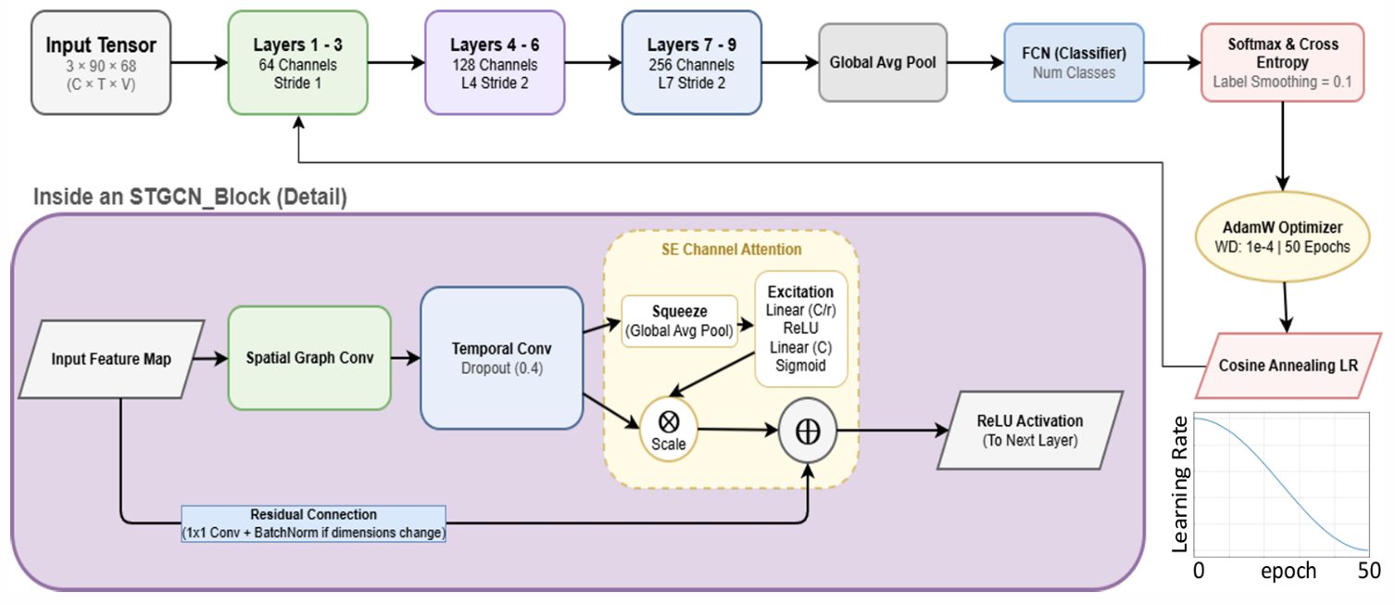
Figure 2 – System Architecture of the SE-STGCN Block
3. Few-Shot Class-Incremental Learning (FSCIL)
- Designed the architecture to support post-deployment vocabulary expansion without requiring resource-intensive retraining or risking catastrophic forgetting.
- Programmatically detached the classification head post-training, utilizing the frozen 9-layer ST-GCN backbone as a pure feature extractor to generate 256-dimensional spatial embeddings.
- Executed a 30-shot prototype-based inference protocol to accurately map and classify completely novel, previously unseen gestures using nearest-neighbor logic.

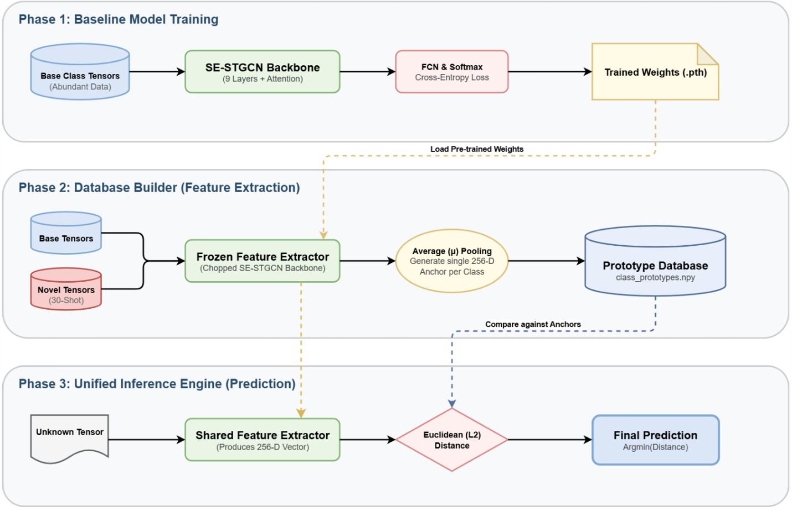
Figure 3 – Three Phase Architecture

4. Empirical Results & Performance Highlights
- Global Accuracy: Achieved 98.46% Strict Accuracy (exact lateral match) and 98.65% Base Sign Accuracy (linguistic core meaning) on a strictly quarantined global test set of 6,840 instances.
- Signer-Independent Stability: Demonstrated robust generalization via 5-fold stratified cross-validation, maintaining an average strict accuracy of 98.61% with a remarkably tight variance of $±0.11\%$.
- Ablation Triumphs: An exhaustive 12-model ablation study proved that the SE Channel Attention module resolves fine-grained geometric bottlenecks (e.g., distinguishing highly similar signs like 'N' and 'M'), definitively outperforming both spatial self-attention and non-attention baselines.
- Real-World Extensibility: The FSCIL protocol successfully integrated completely novel gesture classes, achieving 92.50% test accuracy from only 30 support instances without degrading the performance of the base vocabulary.
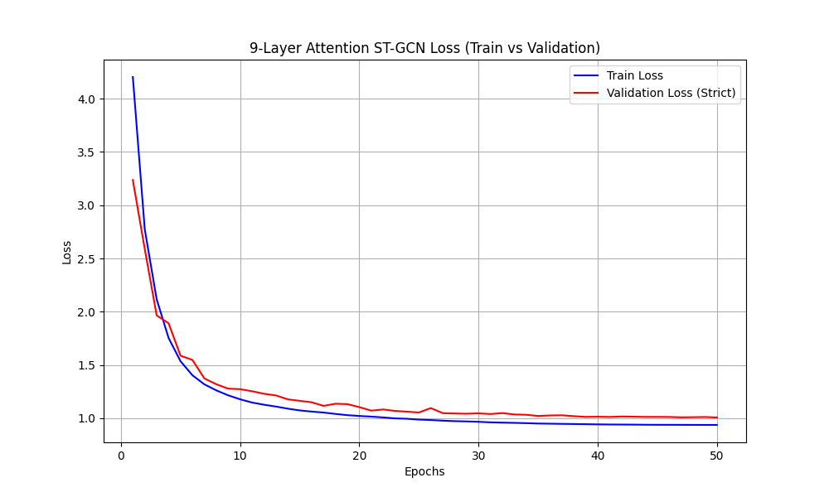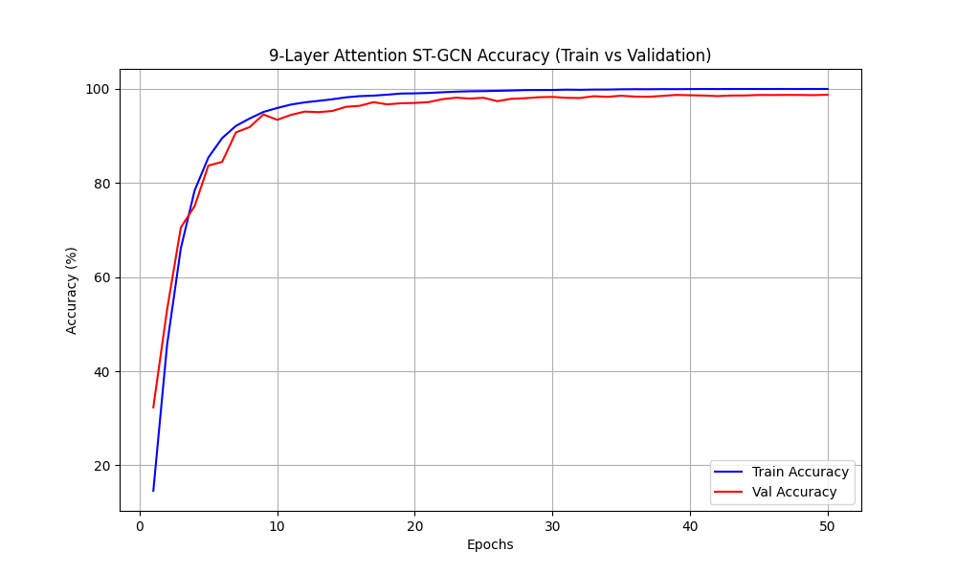
Figure 4-Accuracy and Loss Curves (Train vs Validation)
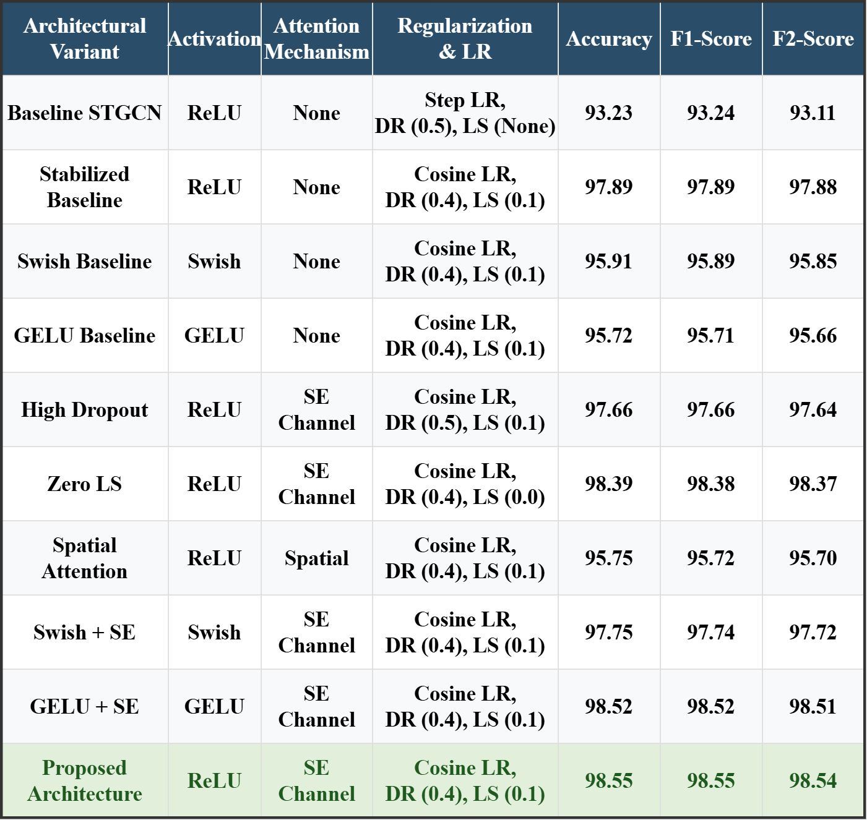
Table 1- Ablation Study Table

